Фотогалерея

20.05.2020

https://trello.com/b/693jhDoX/20052020

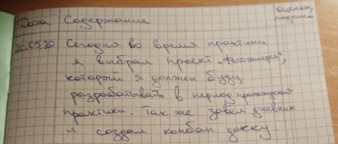

21.05.2020

https://trello.com/b/Sp1uIYf2/21052020

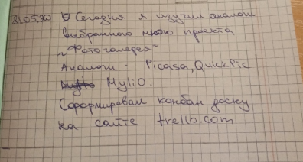

22.05.2020

<https://trello.com/b/vf4zKJ0s/22052020>

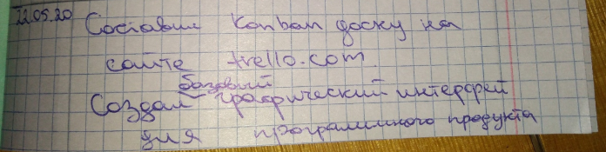

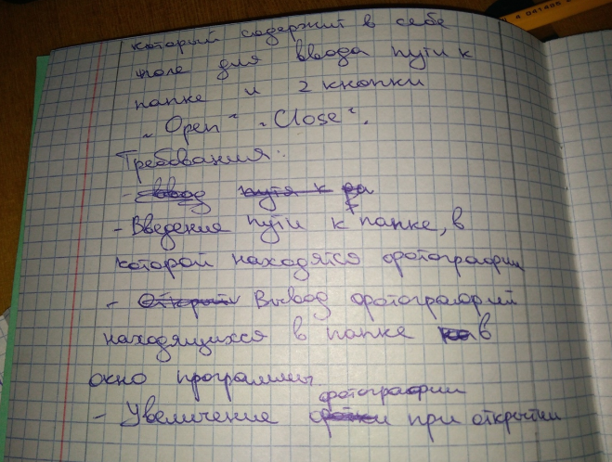

Окно приложения:

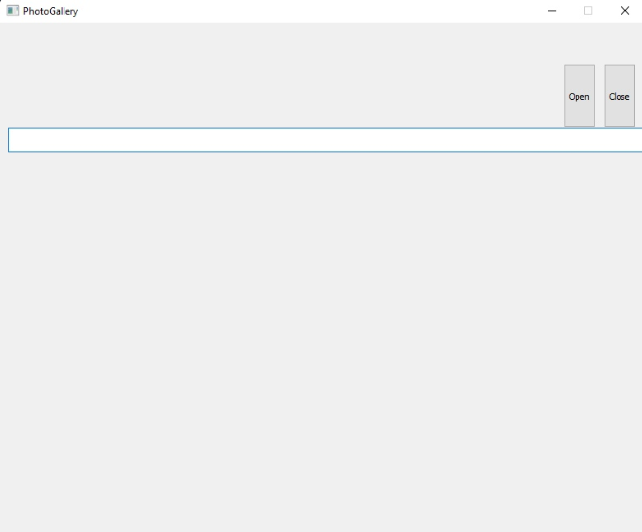

25.05.2020

<https://trello.com/b/q5XFubSD/25052020>

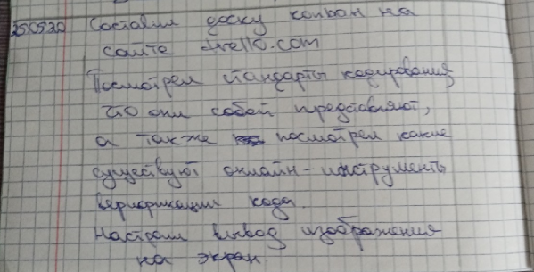

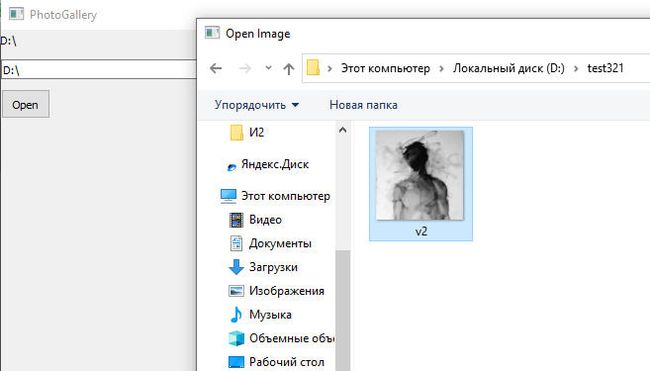

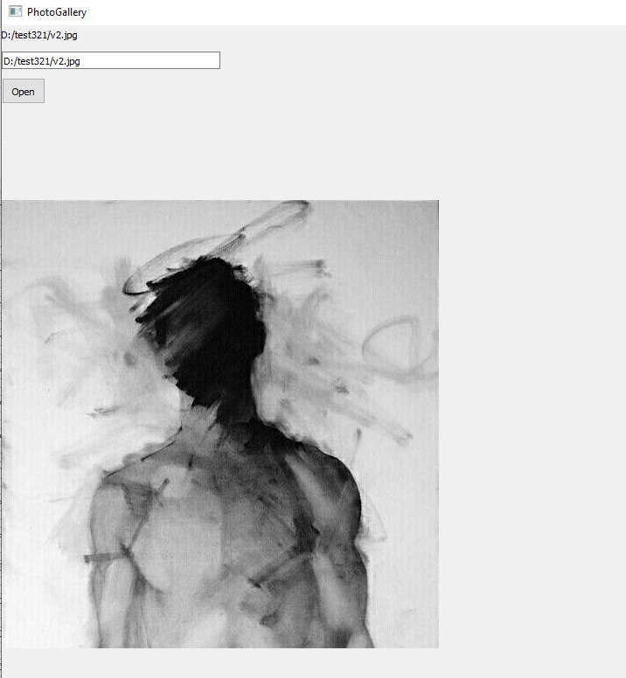

26.05.2020

<https://trello.com/b/fMIA61yG/26052020>

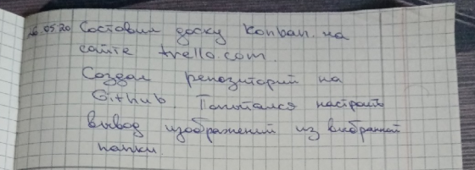

27.05.2020

<https://trello.com/b/mEv4uL2P/27052020>

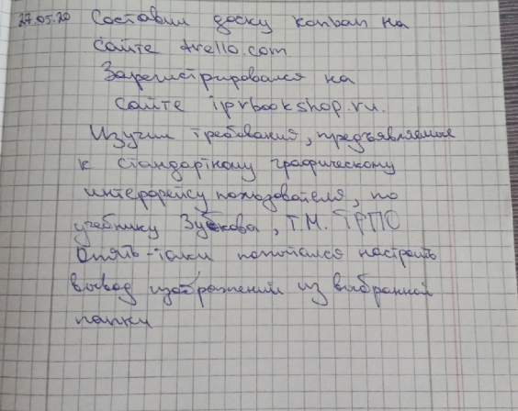

<https://github.com/Syqcle/photogallery>

28.05.2020

<https://trello.com/b/92BAAKDN/28052020>

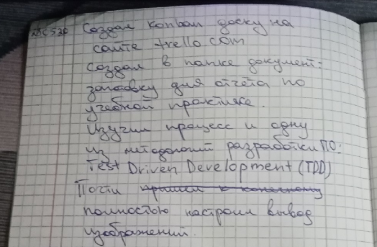

<https://trello.com/b/mpYWiW0i/29052020>

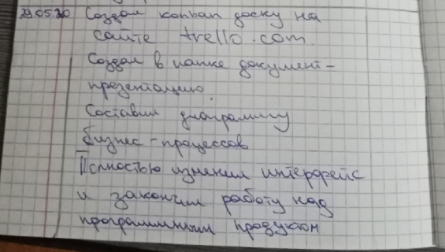

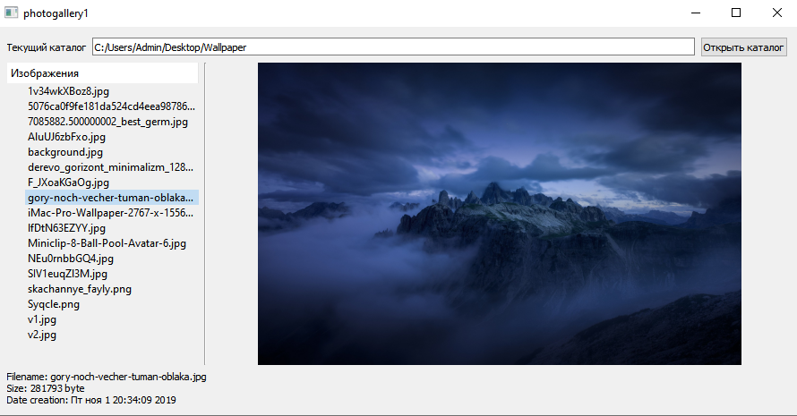

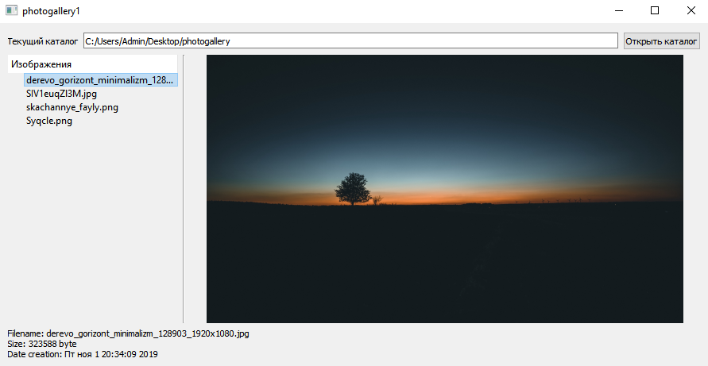

01.06.2020

<https://trello.com/b/JTlb3qkx/01062020>

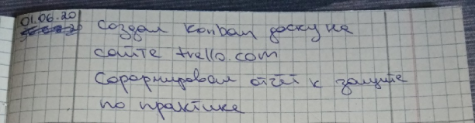

02.06.2020

<https://trello.com/b/eGyGbhiK/02062020>